Student: Gourik Narendra Patil
Email: aartigaurik251@gmail.com
Discord: GNP_29😎

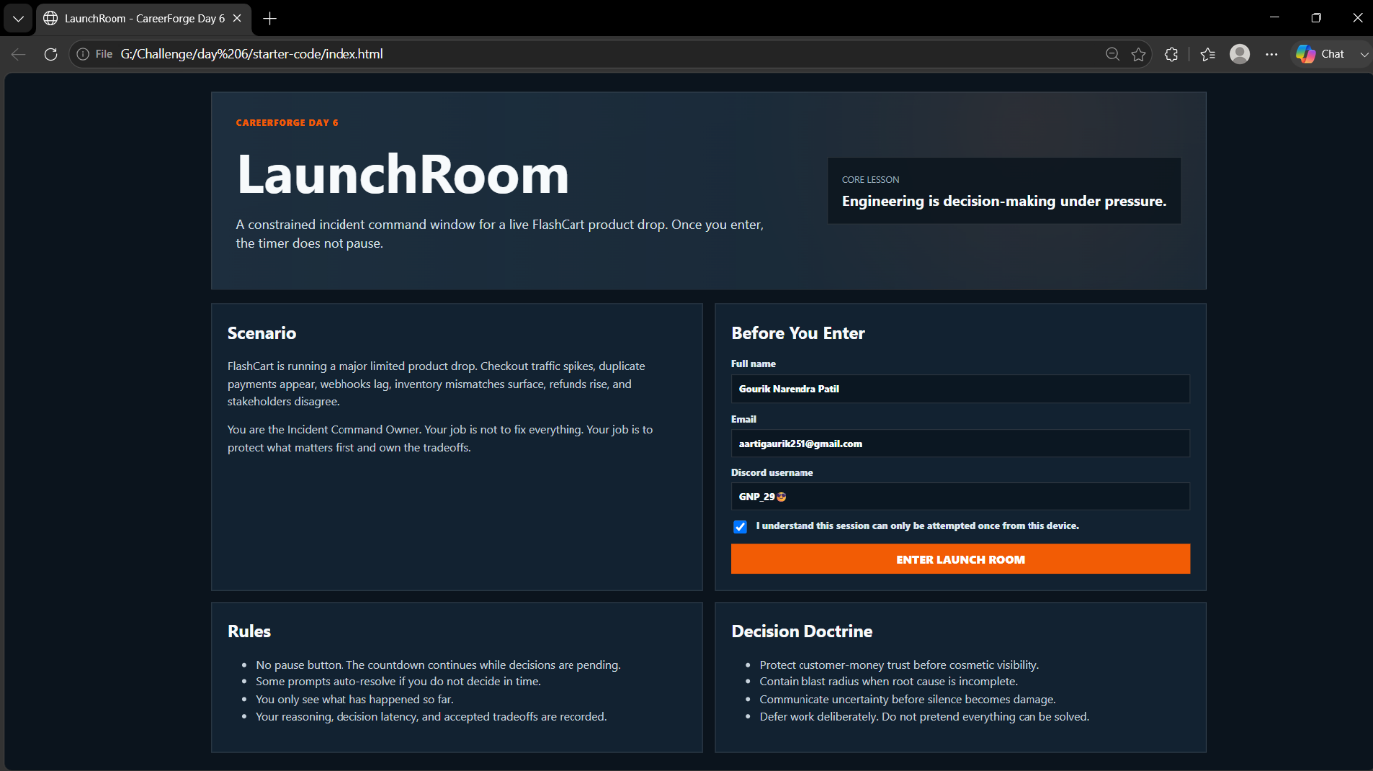

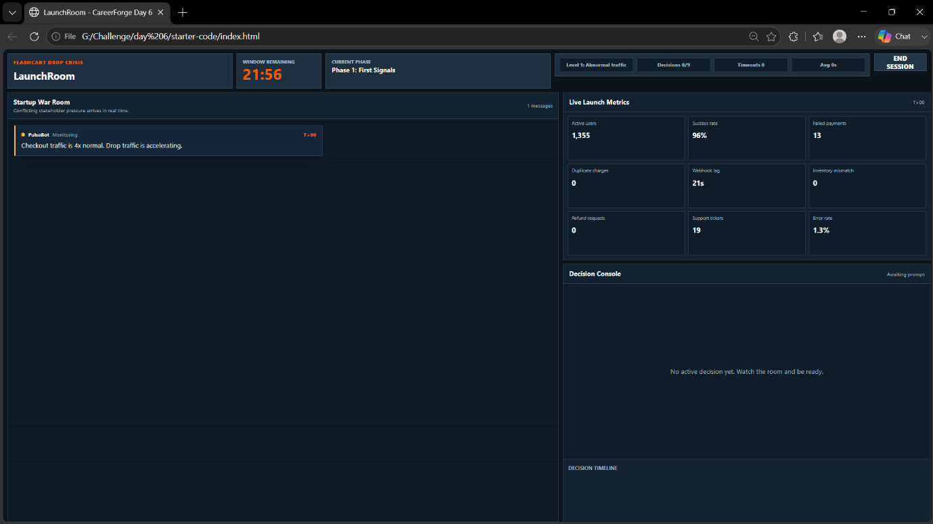

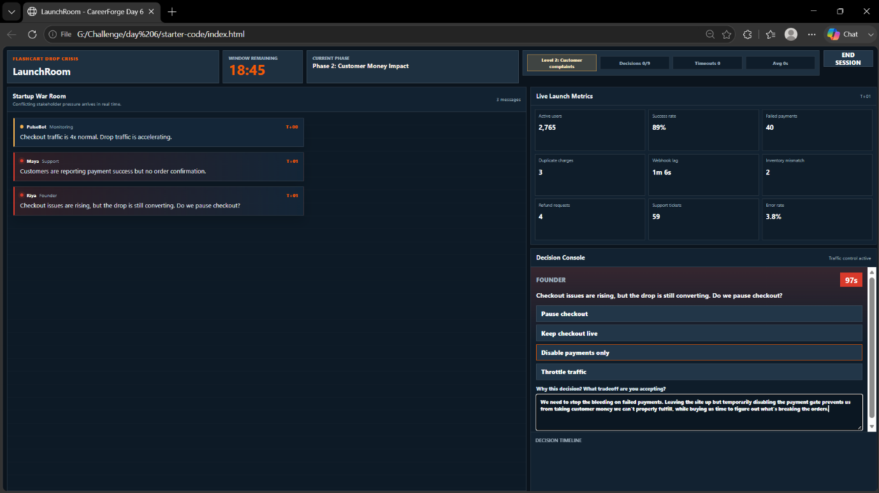

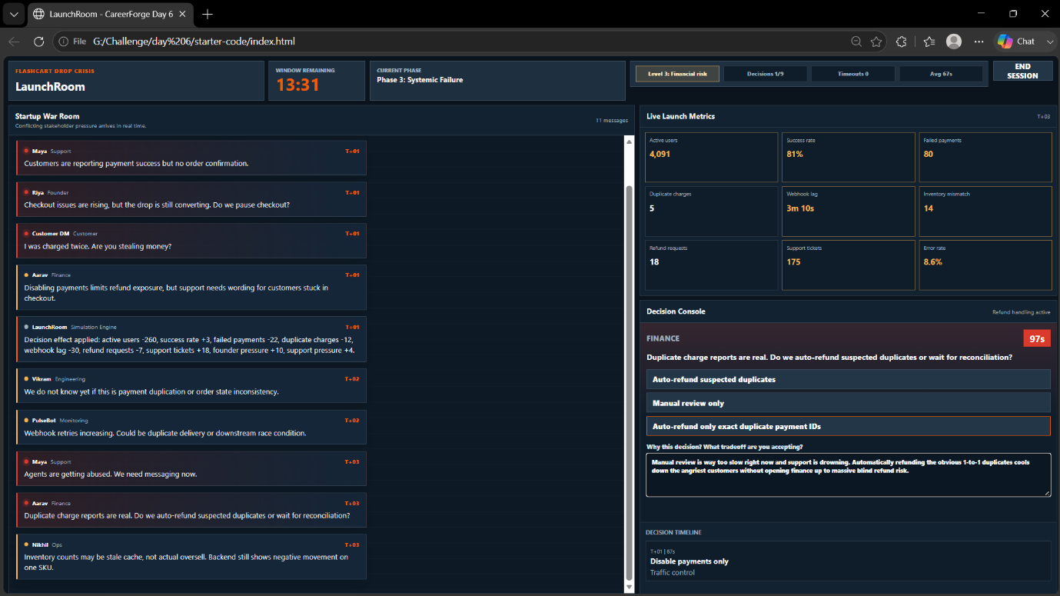
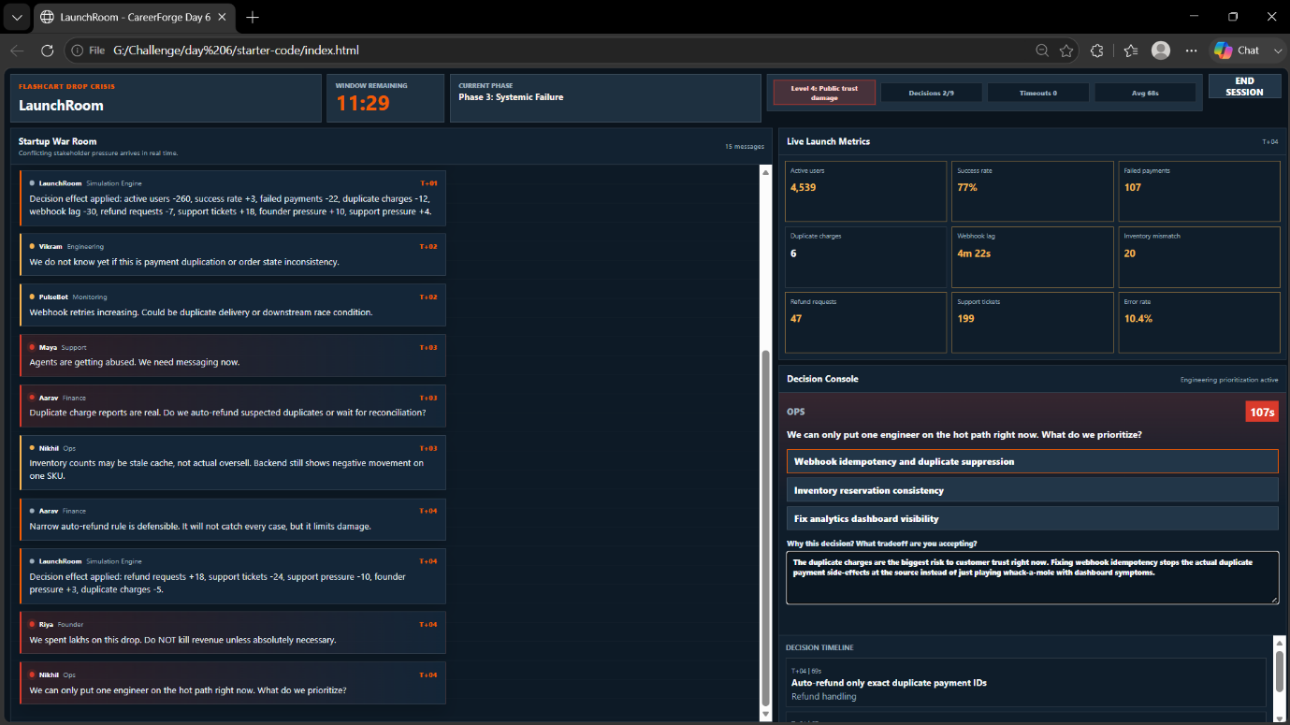

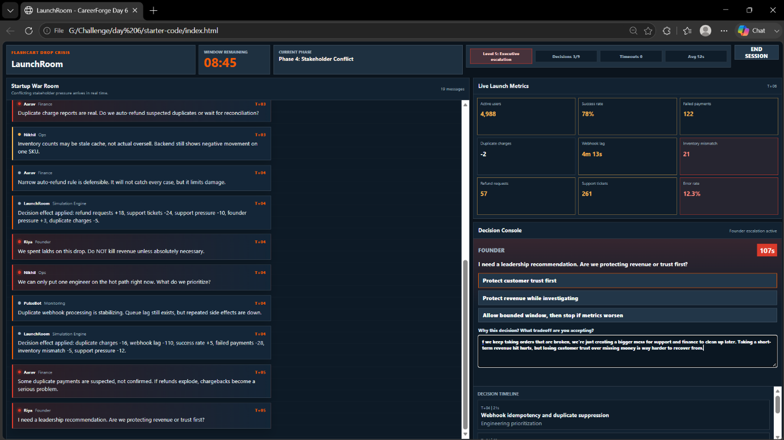

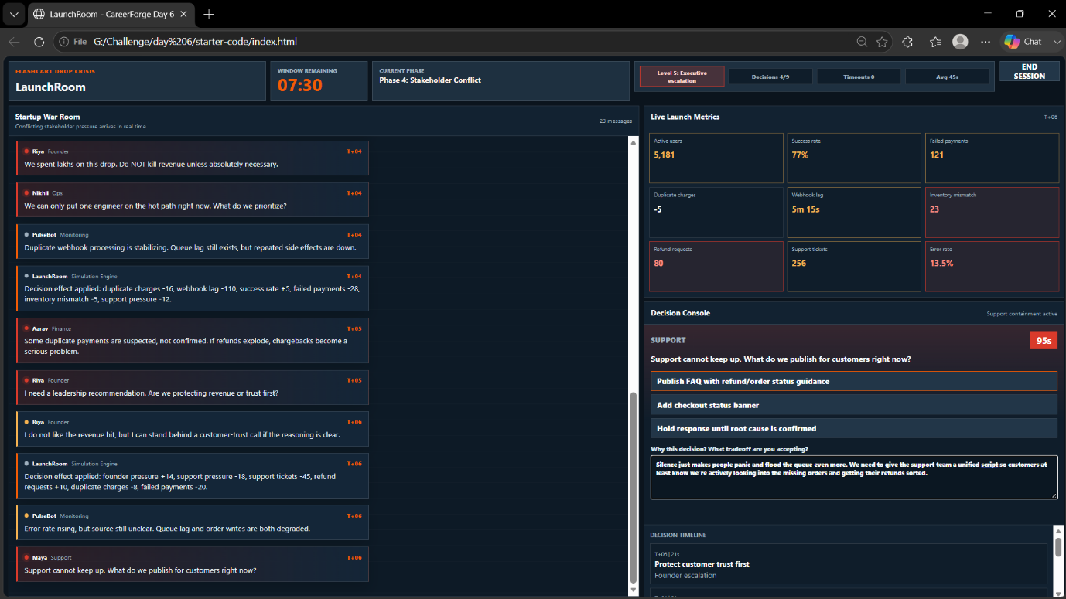

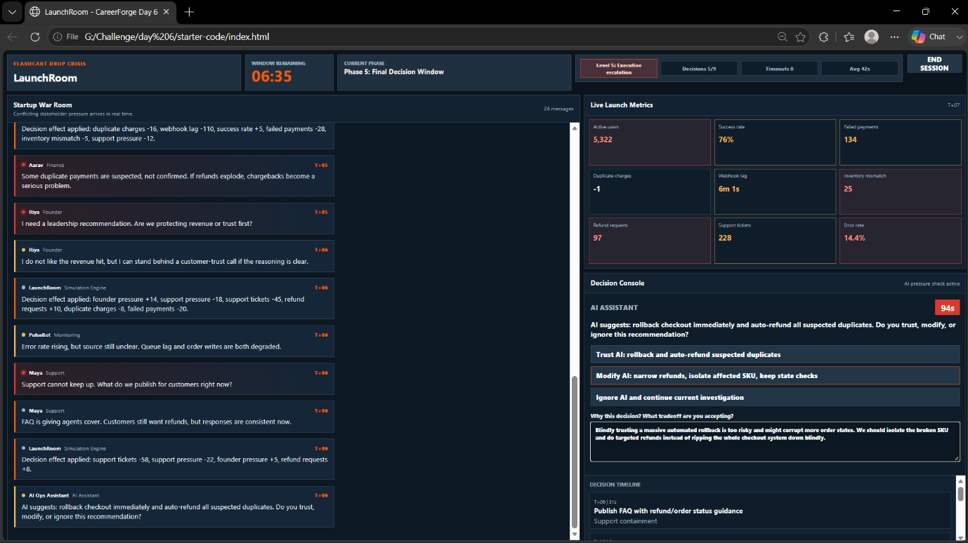

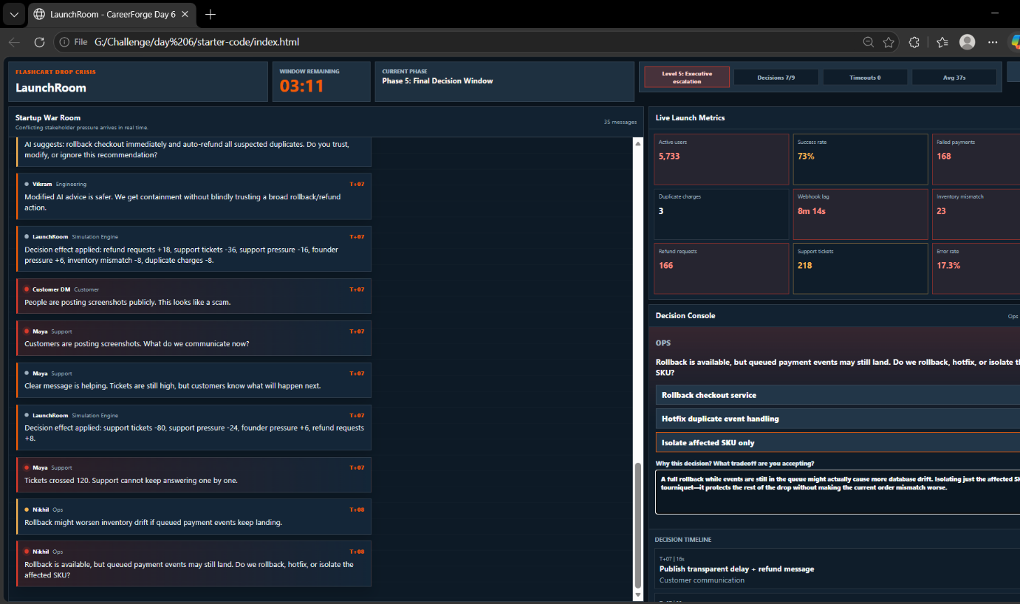

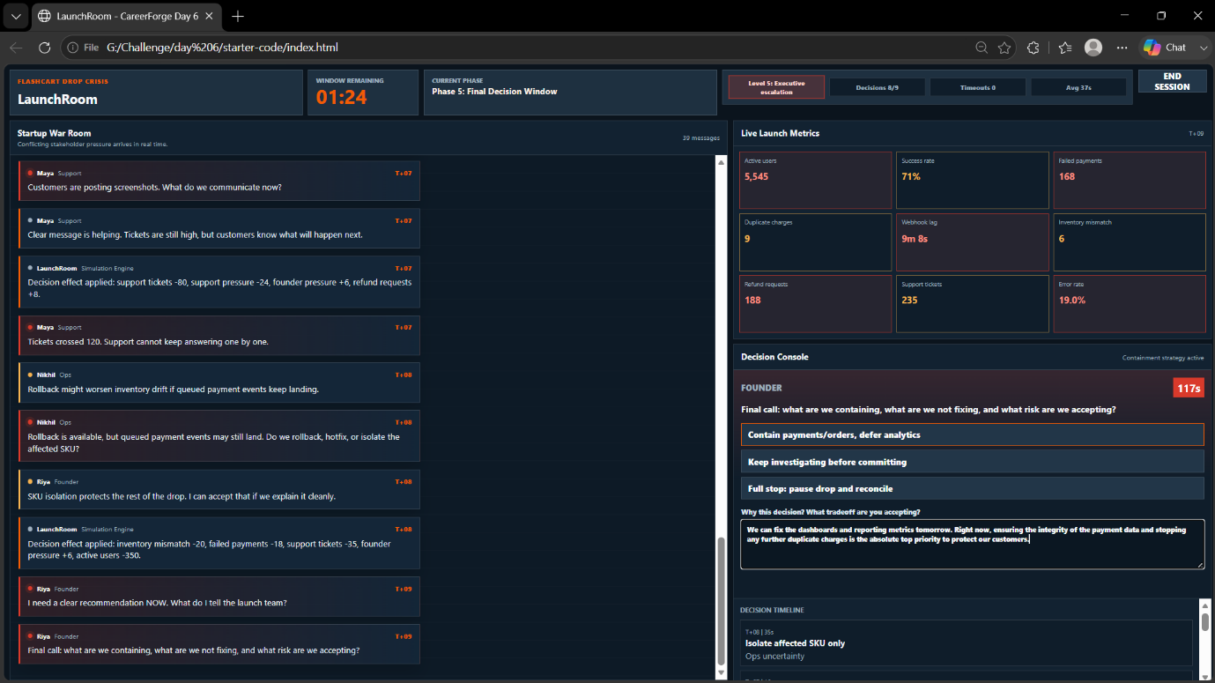

Table of Contents
CareerForge Day 6 Launch Incident Report 6
Generated from LaunchRoom Simulation Decisions 6
Executive Summary 6
Completion Status 6
Incident Overview 6
Primary Incident Factors 6
Strategic Priorities 7
Decision Timeline 7
Metric Impact 7
Incident Prioritization Matrix 13
Critical Priority 13
High Priority 13
High Priority 13
Deferred Priority 14
Current Situation 14
Leadership Assessment 15
Leadership Strengths 15
Leadership Risks 15
Final Portfolio Summary 15

CareerForge Day 6 Launch Incident Report

Generated from LaunchRoom Simulation Decisions

Student: Gourik Narendra Patil
Email: aartigaurik251@gmail.com
Discord: GNP_29😎

Executive Summary
This report documents the FlashCart launch incident simulation completed in LaunchRoom. During a high-traffic product drop, the platform experienced checkout instability, duplicate charge reports, webhook lag, inventory mismatch risk, and escalating support volume.
The response strategy focused on protecting customer trust, containing payment-related risks, minimizing duplicate charges, and reducing the operational impact on support and finance teams. Throughout the incident, customer financial integrity was prioritized over short-term revenue preservation.
The simulation concluded with successful containment of the primary customer-money risks while accepting controlled revenue loss and increased executive pressure.

Completion Status
Status: Ended by student before timer ended

Incident Overview

Primary Incident Factors
- Checkout instability during a high-traffic launch
- Duplicate customer charges
- Payment success without order confirmation
- Webhook processing lag
- Inventory mismatch risk
- Escalating customer support volume
- Public customer complaints and screenshots on social media

Strategic Priorities
- Protect customer money and trust
- Prevent additional duplicate charges
- Restore payment and order consistency
- Reduce support burden through communication
- Limit blast radius while maintaining platform stability

Decision Timeline
T+01 – Traffic Control
Decision
Disable payments only
Reasoning
"We need to stop the bleeding on failed payments. Leaving the site up but temporarily disabling the payment gate prevents us from taking customer money we can't properly fulfill, while buying us time to figure out what's breaking the orders."
Outcome
- Payment creation disabled
- Reduced refund exposure
- Increased customer confusion for active checkouts

Metric Impact
- Active users: -260
- Success rate: +3
- Failed payments: -22
- Duplicate charges: -12
- Webhook lag: -30
- Refund requests: -7
- Support tickets: +18
- Founder pressure: +10
- Support pressure: +4

T+04 – Refund Handling
Decision
Auto-refund only exact duplicate payment IDs
Reasoning
"Manual review is way too slow right now and support is drowning. Automatically refunding the obvious 1-to-1 duplicates cools down the angriest customers without opening finance up to massive blind refund risk."
Outcome
- Targeted refund rule implemented
- Obvious duplicate charges contained
- Some customers still required manual reconciliation
Metric Impact
- Refund requests: +18
- Support tickets: -24
- Support pressure: -10
- Founder pressure: +3
- Duplicate charges: -5

T+04 – Engineering Prioritization
Decision
Webhook idempotency and duplicate suppression
Reasoning
"The duplicate charges are the biggest risk to customer trust right now. Fixing webhook idempotency stops the actual duplicate payment side-effects at the source instead of just playing whack-a-mole with dashboard symptoms."
Outcome
- Duplicate webhook side effects reduced
- Queue lag improved
- Payment consistency stabilized
Metric Impact
- Duplicate charges: -16
- Webhook lag: -110
- Success rate: +5
- Failed payments: -28
- Inventory mismatch: -5
- Support pressure: -12

T+06 – Founder Escalation
Decision
Protect customer trust first
Reasoning
"If we keep taking orders that are broken, we're just creating a bigger mess for support and finance to clean up later. Taking a short-term revenue hit hurts, but losing customer trust over missing money is way harder to recover from."
Outcome
- Customer trust prioritized
- Revenue pressure increased
- Support and customer impact reduced
Metric Impact
- Founder pressure: +14
- Support pressure: -18
- Support tickets: -45
- Refund requests: +10
- Duplicate charges: -8
- Failed payments: -20

T+06 – Support Containment
Decision
Publish FAQ with refund/order status guidance
Reasoning
"Silence just makes people panic and flood the queue even more. We need to give the support team a unified script so customers at least know we're actively looking into the missing orders and getting their refunds sorted."
Outcome
- Consistent customer messaging
- Reduced support workload
- Improved customer handling
Metric Impact
- Support tickets: -58
- Support pressure: -22
- Founder pressure: +5
- Refund requests: +8

T+07 – AI Pressure Check
Decision
Modify AI recommendation: narrow refunds, isolate affected SKU, maintain state checks
Reasoning
"Blindly trusting a massive automated rollback is too risky and might corrupt more order states. We should isolate the broken SKU and do targeted refunds instead of ripping the whole checkout system down blindly."
Outcome
- Safer containment strategy
- Avoided broad rollback risks
- Reduced duplicate charge exposure
Metric Impact
- Refund requests: +18
- Support tickets: -36
- Support pressure: -16
- Founder pressure: +6
- Inventory mismatch: -8
- Duplicate charges: -8

T+07 – Customer Communication
Decision
Publish transparent delay and refund message
Reasoning
"People are already posting screenshots online, so trying to hide behind a generic error message just looks shady. Being upfront about the payment delay builds a bit of trust back and stops the public speculation."
Outcome
- Improved transparency
- Reduced uncertainty
- Lower support escalation
Metric Impact
- Support tickets: -80
- Support pressure: -24
- Founder pressure: +6
- Refund requests: +8

T+08 – Operations Uncertainty
Decision
Isolate affected SKU only
Reasoning
"A full rollback while events are still in the queue might actually cause more database drift. Isolating just the affected SKU acts like a tourniquet—it protects the rest of the drop without making the current order mismatch worse."
Outcome
- Blast radius reduced
- Remaining checkout functionality preserved
- Controlled revenue impact
Metric Impact
- Inventory mismatch: -20
- Failed payments: -18
- Support tickets: -35
- Founder pressure: +6
- Active users: -350

T+09 – Final Containment Strategy
Decision
Contain payments/orders and defer analytics
Reasoning
"We can fix the dashboards and reporting metrics tomorrow. Right now, ensuring the integrity of the payment data and stopping any further duplicate charges is the absolute top priority to protect our customers."
Outcome
- Customer-money risks contained
- Revenue impact accepted
- Analytics work postponed
Metric Impact
- Duplicate charges: -18
- Failed payments: -45
- Support tickets: -60
- Error rate: -4
- Founder pressure: +8
- Support pressure: -18

Incident Prioritization Matrix

Critical Priority
Payment success without order confirmation and duplicate charge pressure
Why it mattered:
Customer money impact required immediate containment and communication.

High Priority
Webhook retries, duplicate events, and inventory mismatch
Why it mattered:
System state consistency issues could generate repeated side effects across payments and inventory.

High Priority
Support ticket growth and public screenshots
Why it mattered:
Customer-facing communication directly affected trust and support load.

Deferred Priority
Analytics and dashboard visibility
Why it mattered:
Visibility issues did not directly affect customer money or order integrity and therefore remained secondary.

Stakeholder Brief

Current Situation
FlashCart experienced checkout instability during a high-traffic limited drop, resulting in payment/order inconsistencies, webhook lag, duplicate charge risk, inventory concerns, and support escalation.
Actions Taken
- Disabled payments
- Auto-refunded exact duplicate payment IDs
- Prioritized webhook idempotency and duplicate suppression
- Chose customer trust over short-term revenue
- Published FAQ guidance
- Modified AI recommendations for safer containment
- Published transparent customer messaging
- Isolated affected SKU
- Deferred analytics restoration
Tradeoffs Accepted
- Temporary revenue loss
- Increased founder pressure
- Reduced support chaos
- Improved customer protection
- Narrowed operational blast radius
- Delayed analytics visibility improvements
Remaining Risks
- Additional customer reconciliation may be required
- Finance review of edge-case duplicate charges
- Engineering follow-up on root causes
- Post-incident process improvements

Performance Assessment
Strong Signals Observed
- Early containment before full escalation
- Customer communication completed during incident
- Strong tradeoff reasoning under pressure
- Fast and consistent decision-making
Risk Signals Observed
- None observed

Leadership Assessment

Leadership Strengths
- Accepted difficult tradeoffs rather than preserving launch momentum
- Prioritized customer trust and payment integrity
- Focused engineering resources on root-cause containment
- Maintained decision velocity under pressure
- Communicated effectively despite uncertainty

Leadership Risks
- None observed

Final Portfolio Summary
During this LaunchRoom simulation, Gourik Narendra Patil made 9 operational incident decisions, managed 9 consequence events, and produced a stakeholder-ready incident response strategy under time pressure.
The simulation demonstrated strong crisis leadership through rapid containment, customer-first decision-making, disciplined engineering prioritization, transparent communication, and effective management of competing stakeholder interests.

